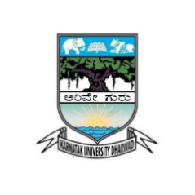
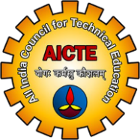
A
PROJECT REPORT ON
“CARVION AI – AI-POWERED CAREER DEVELOPMENT PLATFORM”
SUBMITTED FOR THE PARTIAL FULFILMENT OF THE
REQUIREMENT
FOR THE AWARD OF
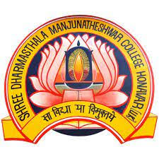
MASTER OF COMPUTER APPLICATIONS

SUBMITTED TO
PG DEPARTMENT OF COMPUTER APPLICATIONS
KARNATAKA UNIVERSITY, DHARWAD

SUBMITTED BY
LOHITH MABLESHWARA MARATHI
REG. NO: P02JH24S126004

UNDER THE GUIDANCE OF
PROF. VANDANA HEGDE
HOD OF MASTER’S OF COMPUTER APPLICATIONS
M.P.E SOCIETY’S S.D.M. DEGREE COLLEGE AND PG STUDIES,
HONNAVAR
ACCREDITED WITH "A+" GRADE BY NAAC
2025 - 2026

